**Inception Specification**

By Noah Ford, Dustin Thompson, Ryan Taylor, Ali Mansoori, Bryce Watson

**System Request**

**Project Sponsor**

Dr. Zara Hatami

Assistant Professor of Practice, Information Systems, Analytics & Operations

University of Louisville, College of Business

Email: [zahra.hatami@louisville.edu](mailto:zahra.hatami@louisville.edu)

**Business Need**

The client, Blue Ridge Animal Rescue & Sanctuary, has expressed a desire to expand its operation. Part of that growth is in the development of a website designed to meet the needs of the client and help fulfill its mission statement:

“Blue Ridge Animal Rescue is a 501(c)(3) charity located in Goshen, KY and is guided by compassion, integrity, and the desire to help mistreated and unwanted animals. We are dedicated to working with and educating the communities we help to make a positive impact on pet overpopulation. Through this labor of love, we rescue, attend to medical, emotional, and behavioral needs, and adapt to appropriate, loving and committed families!”

**Business Requirements**

Through meeting with the client several requirements have been established.

* Website with functionality of:
  + Adopt
  + Support Us
  + Get Involved
  + Resources
* Database built into website including:
  + Animals available
  + Past adoptions
  + Volunteers
  + Potential adopters

**Business Value**

The value derived from the system will be a one stop shop for users, admin, and visitors for an organized database of animals, adopters, and volunteers. The database will be provided and housed by a shelter software company called shelterluv. The additional cost to the client is $2 per adoption and 3.4% plus $0.30 per donation. Shelterluv will work in conjunction with the proposed CMS WordPress. Additionally, there will be a single place for the dissemination of critical information for the client.

These additions will enable the client to capitalize on the market share of non-profit donations. Millennials make up 25.9% of the US population 84% of those are giving $146 annually to a non-profit of their choice. It is also worth noting 47% of millennials gave through an organization's website in 2016. There are similar trends among baby boomers who are giving on average 269 annually to an organization of their choice. Currently our client has only taken in $115 in donations for the year, leaving much opportunity for growing the organization's market share of non-profit donations.

**Special Issues or Constraints**

There will be the need for training on how to update and manage the database and website in general. This training and set up will need to be simplistic in scope so that the average lay person can pick up the task relatively easily.

**Blue Ridge Pet Rescue and Sanctuary**

**Vision (Small Project)**

Version 1.0

Revision History

|  |  |  |  |
| --- | --- | --- | --- |
| Date | Version | Description | Author |
| 09/18/22 | 1.0 | First draft | Bryce Watson |
|  |  |  |  |
|  |  |  |  |
|  |  |  |  |

Table of Contents

1. Introduction 4

2. Positioning 4

2.1 Problem Statement 4

2.2 Product Position Statement 4

3. Stakeholder and User Descriptions 4

3.1 Stakeholder Summary 4

3.2 User Summary 4

3.3 User Environment 5

3.4 Summary of Key Stakeholder or User Needs 5

3.5 Alternatives and Competition 5

4. Product Overview 5

4.1 Product Perspective 5

4.2 Assumptions and Dependencies 6

5. Product Features 6

6. Other Product Requirements 6

**Vision (Small Project)**

Introduction

The purpose of this document is to collect, analyze, and define high-level needs and features of the Blue Ridge Pet Rescue and Sanctuary Project. It focuses on capabilities needed by the stakeholders and the target users, and why these needs exist. The details of how the Blue Ridge Pet Rescue and Sanctuary Project fulfils these needs are detailed in the use-case and supplementary specifications.

Positioning

**Problem Statement**

|  |  |
| --- | --- |
| The problem of | Lack of website for Blue Ridge Pet Rescue and Sanctuary |
| affects | owner and employees |
| the impact of which is | Less outreach and funding from the community |
| a successful solution would be | A website which can support multiple business processes needed for Blue Ridge Pet Rescue and Sanctuary to succeed |

**Product Position Statement**

|  |  |
| --- | --- |
| For | Blue Ridge Pet Rescue and Sanctuary |
| Who | Needs an online presence to increase growth |
| The (product name) | Blue Ridge Pet Rescue and Sanctuary Project is a website |
| That | Will allow users and customers to reach out to the company to interact and support its efforts |
| Unlike | Staying off the internet and processing business needs through in-person interaction |
| Our product | Will open doors for the company to reach many other users and people who are willing to help |

**Stakeholder and User Descriptions**

Previously, business was conducted in-person and meant that many users and customers were unable to reach or know that the company existed. This project will help to broaden the reach of the company to obtain users and customers throughout the community by giving them access to a website which will have a major benefit to the company. A website can help to increase donations by 54%. It will also allow for subscription-based donations which can increase donations by another 42%. A website will also help to increase the chance of getting grants by 50%. Grants are a huge funding source, averaging $11,000 for the largest grant.

**Stakeholder Summary**

|  |  |  |
| --- | --- | --- |
| Name | Description | Responsibilities |
| Kim Dehler | Owner of Blue Ridge Pet Rescue and Sanctuary | Manages the company and approves all funding and resources |
| Volunteers | Volunteers of Blue Ridge Pet Rescue and Sanctuary | Volunteers who help with the basic processes of the company |

**User Summary**

|  |  |  |  |
| --- | --- | --- | --- |
| Name | Description | Responsibilities | Stakeholder |
| Customers | Users who interact with the company via adoptions or donations | They help to fund and promote the company through communication with the business and with others | This user is directly represented by the developers of the service who intend to increase customer and user outreach with a functional website. |

**User Environment**

Users will be able to interact with the website to complete their activity. These activities range from adoption, volunteering, communicating with the business, donating, and more. These actions will usually only take a few minutes to an hour. The website will allow for both desktop and mobile users to easily connect and interact with it. Integration with payment systems will be needed to process donations and a future store. A mailing list might also be needed to send out newsletters.

Summary of Key Stakeholder or User Needs

|  |  |  |  |  |  |
| --- | --- | --- | --- | --- | --- |
| Need | Priority | Concerns | Current Solution | Proposed Solutions | |
| Broadcast messages | Medium | Reach out to users with a newsletter | None | | Implement a mailing system to reach out to users |
| Audience reaches | High | Reach users across multiple different platforms | Word of mouth | | Create a website and display it in search engines to reach out to users on the internet |
| Operational efficiency | High | Increase adoption, volunteer, and donation efficiency | In-person communications | | Use of a website to display adoptions; use of website to accept volunteer applications; use of payment system to process donations |
| Cost | Very high | Keep costs low while producing an effective product | No website in place | | Ensure that the costs of the website will be outweighed by its economic benefits (increased donations/adoptions) |

**Alternatives and Competition**

Alternative solutions like social media are effective, but they are useless if you do not have an online webpage to link users to. It is much more effective for users to be sent to a website to interact rather than being sent to a location to interact. While social media would be a highly effective complement to a website, it is extremely ineffective on its own. A website will help to increase traffic by about 87% for the first year.

**Product Overview**

**Product Perspective**

This system is self-contained and meant to be the primary communication between the business and its users. The customers and the end users who will use the website to locate the services they are looking for (adoption, donation, volunteering, etc.).

**Assumptions and Dependencies**

This product assumes the existence of available website design functions for creation of the major site, as well as a payment system to process donations. It also assumes that there is sufficient funding to run the website and developers who can maintain it.

**Product Features**

A tab to support the showing of adoptions, with the ability to add and remove at will

A tab to support donations using online means or instructions to send physical payments

A tab to support volunteer opportunities, via an automatic submission form or some other processing means

A tab to support mailing lists to send out newsletters

A tab to show about us information

A team that will manage the website in the future

**Other Product Requirements**

This system will require a professionally created web environment where users are able to confidently interact with the webpage and feel secure when doing so. Users should be able to quickly access information they need without delays or interruptions to service. The service will need to be scalable to ensure that any additions are easily added without major core changes.

**Process Models**

**As Is:**

The current business process of Blue Ridge Animal Rescue is by use of Facebook and Petfinder. These third-party platforms do not give the organization its streamlined design for better user experience and missing major parts. Currently clients use these platforms to select animals but manually fill application through email, or by use of Petfinder as redirect to select animals for adoption.

**To Be:**

The To-Be business process modules takes the current way of business process and adds a lot more features for better streamlines design and user experience. By use of its own website that has no redirect, it adds adoption, donation, and volunteer in one place for user to and admin to access information faster than before.

**System Requirements**

The system requirements are a series of high-level requirements detailing product features to be found in the vision document. The requirements are split into functional and nonfunctional categories. Functional requirements detail physical items to be found in the product such as an adopt tab. Nonfunctional requirements detail nontangible items such as security.

Functional Requirements

1. Support Us Tab
   1. – The Support Us tab will allow donors to register.
   2. – The Support Us tab will accept payments from donors through the PMS.
   3. – The Support Us tab will allow donors to deregister.
   4. – The Support Us tab will instruct donors how to send physical payments.
   5. – The Support Us tab will list physical donations needed.
   6. – The Support Us tab will allow donors to donate in the memory of.
   7. – The Support Us tab will allow instruct donors how to donate smile cards.
2. Adopt Tab
   1. – The adopt tab will list animals from the database available for adoption.
   2. – The adopt tab will allow adopters to register interest in animals.
   3. – The adopt tab will allow adopters to electronically file applications.
   4. – The adopt tab will provide instructions to send physical applications.
   5. – The adopt tab will allow adopters to withdraw applications.
3. Get Involved Tab
   1. – The Get Involved tab will list volunteer opportunities.
   2. – The Get Involved tab will allow users to register as volunteers.
   3. – The Get involved tab will allow users to update volunteer information.
   4. – The Get Involved tab will allow users to deregister as volunteers.
   5. – The Get Involved tab will allow admin to create newsletters.
   6. – The Get Involved tab will allow admin to edit newsletters.
   7. – The Get Involved tab will allow admin to delete newsletters.
   8. – The Get Involved tab will allow users to view newsletters.
4. Resources Tab
   1. – The resources tab will list information on animal care, training, etc.
   2. – The resources tab will allow admin to create FAQs (Frequently Asked Questions).
   3. – The resources tab will allow admin to edit FAQs.
   4. – The resources tab will allow admin to delete FAQs.
   5. – The resources tab will allow users to query FAQs.
5. Database
   1. – The database will compile a list of donors.
      1. – The database will allow users to add donors.
      2. – The database will allow users to edit donors.
      3. – The database will allow users to remove donors.
   2. – The database will compile a list of animals.
      1. – The database will allow users to add animals.
      2. – The database will allow users to edit animals.
      3. – The database will allow users to remove animals.
   3. – The database will compile a list of adopters.
      1. – The database will allow users to add adopters.
      2. – The database will allow users to edit adopters.
      3. – The database will allow users to remove adopters.
   4. – The database will compile a list of volunteers.
      1. – The database will allow users to add volunteers.
      2. – The database will allow users to edit volunteers.
      3. – The database will allow users to remove volunteers.
   5. – The database will compile a list of Foster Families.
      1. – The database will allow users to add foster families.
      2. – The database will allow users to edit foster families.
      3. – The database will allow users to delete foster families.
   6. – The database will compile a list of rescue events.
      1. – The database will allow users to create rescue events.
      2. – The database will allow users to edit rescue events.
      3. – The database will allow users to delete rescue events.

Nonfunctional Requirements

1. Operational
   1. – The website should be accessible from a variety of platforms including mobile
   2. – The website should interface with the PMS
   3. – The website should be easy to maintain and update.
2. Security
   1. – The system should be updated regularly to mitigate breaches.
   2. – The database should be accessed only by authorized users to protect sensitive information.
3. Performance
   1. Donations should be easy to complete with minimal steps.
   2. Website should run smoothly on all platforms including mobile.

**Use Cases**

**Use Case 1: Create Donor**

Description: Donors will be able to register accounts

Actor: Donor

Risk Level: Low

**Use Case 2: Create Donation**

Description: Donors can donate using the PMS

Actor: Donor

Risk Level: High

**Use Case 3: Delete Donor**

Description: Donors will be able to delete their accounts

Actor: Donor

Risk Level: Low

**Use Case 4: Create Physical Donation**

Description: Donors can view instructions for physical donations

Actor: Donor

Risk Level: High

**Use Case 5: Create Physical Donation List**

Description: List items needed for physical donation

Actor: Administrators

Risk Level: High

**Use Case 6: Create Adoption List**

Description: List animals up for adoption

Actor: Administrators

Risk Level: High

**Use Case 7: Create Adoption Registration**

Description: Website users can opt in to register interest in animals

Actor: Website users

Risk Level: Low

**Use Case 8: Create Adoption Application**

Description: Website users can fill out an application electronically

Actor: Website users

Risk Level: High

**Use Case 9: Create Physical Adoption Application**

Description: Website users can get instructions to fill out a physical application

Actor: Website users

Risk Level: Low

**Use Case 10: Delete Adoption Application**

Description: Website users can withdraw their electronic applications

Actor: Website users

Risk Level: Low

**Use Case 11: Create Volunteer Opportunities**

Description: Administrators can create adoption opportunities

Actor: Administrators

Risk Level: High

**Use Case 12: Create Volunteers**

Description: Volunteers can register

Actor: Volunteer

Risk Level: High

**Use Case 13: Edit Volunteers**

Description: Volunteers can edit their information

Actor: Volunteer

Risk Level: Low

**Use Case 14: Delete Volunteers**

Description: Volunteers can delete their accounts

Actor: Volunteer

Risk Level: Low

**Use Case 15: Create Resources**

Description: Create lists for animal care, training, and other resources

Actor: Administrators

Risk Level: Low

**Use Case 16: Edit Resources**

Description: Edit lists for animal care, training, and other resources

Actor: Administrators

Risk Level: Low

**Use Case 17: Delete Resources**

Description: Delete lists for animal care, training, and other resources

Actor: Administrators:

Risk Level: Low

**Use Case 18: Create Donors in Database**

Description: Users can be created as donors in the database

Actor: Administrators

Risk Level: High

**Use Case 19: Edit Donors in Database**

Description: Users can be edited as donors in the database

Actor: Administrators

Risk Level: Low

**Use Case 20: Delete Donors in Database**

Description: Users can be deleted as donors in the database

Actor: Administrators

Risk Level: Low

**Use Case 21: Create Animals in Database**

Description: Administrators can add animals to the database

Actor: Administrators

Risk Level: High

**Use Case 22: Edit Animals in Database**

Description: Administrators can edit animals in the database

Actor: Administrators

Risk Level: High

**Use Case 23: Delete Animals in Database**

Description: Administrators can delete animals in the database

Actor: Administrators

Risk Level: High

**Use Case 24: Create Adopters in Database**

Description: Users can be created as adopters in the database

Actor: Administrators

Risk Level: High

**Use Case 25: Edit Adopters in Database**

Description: Users can be edited as adopters in the database

Actor: Administrators

Risk Level: Low

**Use Case 26: Delete Adopters in Database**

Description: Users can be deleted as adopters in the database

Actor: Administrators

Risk Level: Low

**Use Case 27: Create Volunteers in Database**

Description: Users can be created as volunteers in the database

Actor: Administrators

Risk Level: High

**Use Case 28: Edit Volunteers in Database**

Description: Users can be edited as volunteers in the database

Actor: Administrators

Risk Level: Low

**Use Case 29: Delete Volunteers in Database**

Description: Users can be deleted as volunteers in the database

Actor: Administrators

Risk Level: High

**Use Case 30: Create FAQ (Frequently Asked Questions)**

Description: Create FAQs

Actor: Administrators

Risk Level: Low

**Use Case 31: Edit FAQ**

Description: Edit FAQs

Actor: Administrators

Risk Level: Low

**Use Case 32: Delete FAQ**

Description: Delete FAQs

Actor: Administrators

Risk Level: Low

**Use Case 33: Query FAQ**

Description: Users can search FAQs

Actor: Website users

Risk Level: Low

**Use Case 34: Create Newsletter**

Description: Create newsletters

Actor: Administrator

Risk: Low

**Use Case 35: Edit Newsletter**

Description: Edit newsletters

Actor: Administrator

Risk: Low

**Use Case 36: Delete Newsletter**

Description: Delete newsletters

Actor: Administrator

Risk: Low

**Use Case 37: Donate in Memory of**

Description: Submit a donation in the name of an individual or family

Actor: User

Risk: Low

**Use Case 38: Donate a Smile Card**

Description: user donates using a smile card

Actor: User

Risk: Low

**Use Case 39: Create Foster Family in Database**

Description: Adding foster family data to database

Actor: User

Risk: High

**Use Case 40: Edit Foster Family in Database**

Description: Change the information of foster families in the database

Actor: User

Risk: Low

**Use Case 41: Delete Foster Family in Database**

Description: Delete the information of foster families in the database

Actor: User

Risk: Low

**Use Case 42: Create Rescue Events in Database**

Description: Create events that the Rescue will be hosting or participating in

Actor: User

Risk: Low

**Use Case 43: Edit Rescue Events in Database**

Description: Edit events that the Rescue will be hosting or participating in

Actor: User

Risk: Low

**Use Case 44: Delete Rescue Events in Database**

Description: Delete events that the Rescue hosted or participated in

Actor: User

Risk: Low

Trace Matrix

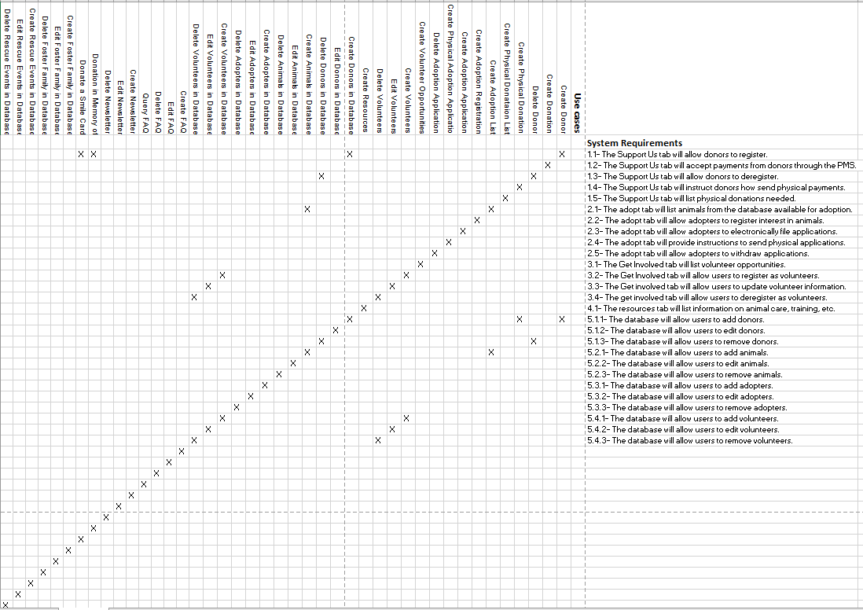

**Initial Architecture**

The first architecture is a rough draft of how the traffic and network of the site will look including all the parts that go into the website like the Cloud, PMS, CMS, etc. The second architecture is a more realized looking model including google workspace since it free and has a strong security team that provide amazing coverage of the cloud and attacks, ShelterLuv helping to make the database more organized by having features such as a task list and a medical feature to keep track of medical needs, Bluehost being the secure host and having an SSL certificate to protect the site from issues and to allow for possible upgrades in the future, and CSG Forte helps organize purchases and has an affordable rate to keep from taking away from the donations.

USER



Internet



 **Firewall Server**



**Cloud** **Website**  **PMS**



Website Host**

USER



Internet



 **Bluehost Firewall Server**



**Google Workplace****Website**  **CSG**  **Forte**



Bluehost**

**Risk Analysis**

A risk analysis is a process that involves identifying risks and potential issues to an organization's business goals and processes. This process is helpful in determining where security is important, and where the project team should focus efforts. Everything listed in a risk analysis is important for the success of the organization or business, it just helps put everything into scope for the organization. It is important to note that even though below we only have high and low risk cases listed below, an organization could separate the risks identified in various risk levels.

High risk cases and low risk cases are defined in the use cases listed above. Higher risk items contain more sensitive data such as names, health records, bank account numbers and money amounts. Lower risk items are usually editing or deleting secured, stored data or creating low risk items that have no sensitive information in them. Both cases are necessary for the success of the animal rescue, but high-risk cases should be prioritized. High risk cases contain more sensitive data and the income through donations for Blue Ridge Animal Rescue & Shelter. These cases are more critical to the success of the organization and should be the focus of our efforts in future iterations.

High Risk Cases

* Create Donation
* Create Physical Donation
* Create Physical Donation List
* Create Adoption List
* Create Adoption Application
* Create Volunteer Opportunities
* Create Volunteers
* Create Donors in Database
* Create Animals in Database
* Edit Animals in Database
* Delete Animals in Database
* Create Adoptions in Database
* Create Volunteers in Database
* Delete Volunteers in Database
* Create Foster Family in Database

Low Risk Cases

* Create Donor
* Delete Donor
* Create Adoption Registration
* Create Physical Adoption Application
* Delete Adoption Application
* Edit Volunteers
* Delete Volunteers
* Create Resources
* Edit Resources
* Delete Resources
* Edit Donors in Database
* Delete Donors in Database
* Edit Adopters in Database
* Delete Adopters in Database
* Edit Volunteers in Database
* Create FAQ (Frequently Asked Questions)
* Edit FAQ
* Delete FAQ
* Query FAQ
* Create Newsletter
* Edit Newsletter
* Delete Newsletter
* Donate in Memory Of
* Donate a Smile Card
* Edit Foster Family in Database
* Delete Foster Family in Database
* Create Rescue Events in Database
* Edit Rescue Events in Database
* Delete Rescue Events in Database

**Team Charter**

**Team Goals**

The top goal of this team is to help our client get the animals under her care to be adopted. To accomplish this goal, several subgoals will need to be met. These subgoals include finding new avenues of reaching people through new social media applications and a website which highlights both the organization and the animals, obtain funding through donations to better care for the animals and meet the client’s long-term goal of having a building for the animals, and lastly is to streamline the client's documentation into online services instead of several computer applications and paper documents.

**Team Meetings**

Team meetings will be primarily held through Microsoft Teams, and in person when needed. In the interest of balancing school and work, we will not have a set meeting time weekly, but will meet as often as necessary for each stage of this project. Meetings will be held if most of the team can meet, with notes being taken to fill in those who were unable to attend.

Short, informational, and task-oriented meetings will be held every class session to ensure that the team stays on track to complete the project according to the specifications provided to us by the client, Kim Dehler, and grading rubrics.

**Team Communication**

Communication between team members will occur through Microsoft Teams, GroupMe, or after the instruction for the day has ended in class. Communication between our team and the professor will occur through email or face to face conversation before/after class. Communication between our team and the client will occur whenever the client is in class. Clear communication is important for the success of this team, so we will strive to ensure that our communication is both clear and timely.

**Team Decision Making**

As with any team, conflict and disagreements will inevitably occur when we need to decide on a course of action. As such, we believe the best course of action in this case is to put the issue to a majority vote, after the two opposing parties clearly explain their viewpoint. If the vote fails, we will enter discussions once again and revote. If the vote fails a second time, we will seek a third party to mediate for us. This will ensure that a decision is made in a timely way, and we can move on to other aspects of the project.

We do not expect to have any issues on coming to a decision as we are all on the same page as what we need to do to complete this project. The decisions we make will be made on the wishes, needs, and feedback of the client, Kim Dehler, as ultimately, this project is for her animal rescue.

**Team Repository**

All team documents will be stored on Microsoft Teams so that every member of the team can access and edit the documents. Edits will be saved and available to every team member. Files and documents will be sorted into folders, so we know exactly where a specific document is stored. Each iteration of the project will be stored in a separate folder, clearly marked as Iteration 1. Subfolders will contain individual work for each iteration and another subfolder for sample documents.

**Team Documents**

Each phase has several deliverables that need to be completed. This work will be divided amongst the team members. Each team member will be responsible for creating their respected documents accurately and on time. All team members will review the work of the others to ensure mistakes are corrected and improvements are made. After each of the deliverables are completed, they will be compiled into one document for overall review, correction, and formatting. After phase submission and phase presentations, the team will go back through the compiled documents and edit them according to feedback received. This will be a continuous process throughout the duration of the project.

**Gantt Chart**

The following information is a Gantt chart highlighting the deliverables of Iteration 2. This chart shows what is involved in each deliverable, the start and end dates, duration of the task, who is responsible for completing said task, what this task is dependent on, and finally the status of the task. This allows for the project team to visually see the tasks needed to be completed and will allow the team to remain on schedule by completing tasks by the indicated finish date. Having a graphical representation will show us which tasks can be completed simultaneously and which tasks are in the queue to be completed after preceding tasks. Each task is identified with a unique task ID# so we can easily reference between the chart and the data set.

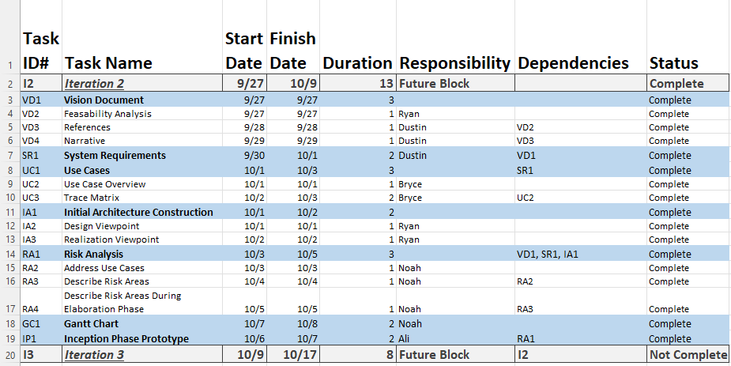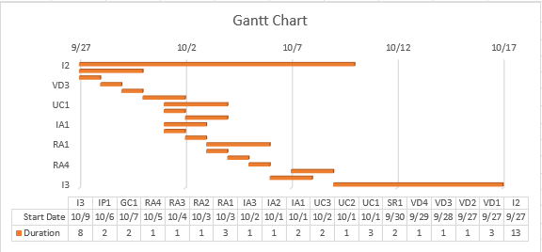

**Inception Phase Prototype**

These are three high level prototypes coded in HTML that represent the business process of the website. Adoption form, volunteers form, and donation form.

**ADOPTION FORM**

Text BoxText BoxText BoxName*

Text BoxAddress*

Text BoxText BoxText Box

Text BoxEmail*

Text Box

Phone Number*

Phone Type*

* Cell
* Home
* Work

Do You Currently Have any Pets?

* Yes
* No

If yes, Please List them below.

Text Box

Would you like to sign up to receive Newsletters?

Text BoxText BoxText BoxYes No

**Volunteers Registration Form**

Text BoxText BoxText BoxName*

Gender*

* Male
* Female
* Text BoxRather Not Specify

Date of Birth*

Text BoxPhone Number*

Phone Type*

* Cell
* Home
* Text BoxWork

Education*

Text BoxAddress*

Text BoxText BoxText Box

Text BoxEmail*

Preferred Hours Per Week*

* 2 hours
* 4 hours
* 6+ hours

Text BoxPreferred days*

Text BoxText BoxText BoxText BoxText BoxText BoxMonday Tuesday Wednesday Thursday Friday Saturday Sunday

Would you like to sign up to receive Newsletters?

Text BoxText BoxText BoxYes No

**Donation Form**

Text BoxText BoxText BoxName*

Text BoxEmail*

Text Box

Phone Number*

Type of Donation*

* Food
* Clothes
* Toy
* Payment Donation

Comments

Text BoxText BoxText BoxText BoxDonation Amount*

Payment Method

* Debit
* Credit

Text BoxEnter Card Number*

Text BoxText Box

Would you like to sign up to receive Newsletters?

Text BoxText BoxYes No

Text Box